**Website instructions**

**Problem Definition**

Background and Need for Home Interior Website

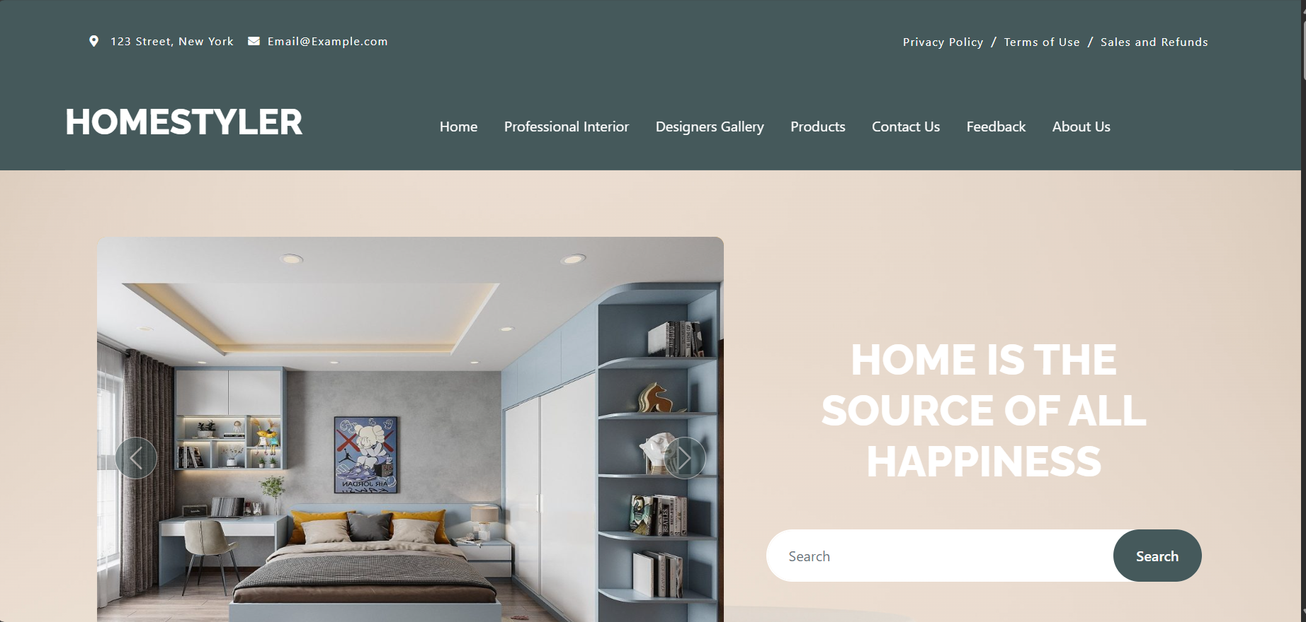

As modern home interiors have become increasingly popular, individuals often find themselves overwhelmed with various design options, furniture choices, and decor elements.

This is where a dedicated home interior Website can provide significant value and convenience to users. Some reasons how such a Website can be useful are as follows:

**Centralized Platform:**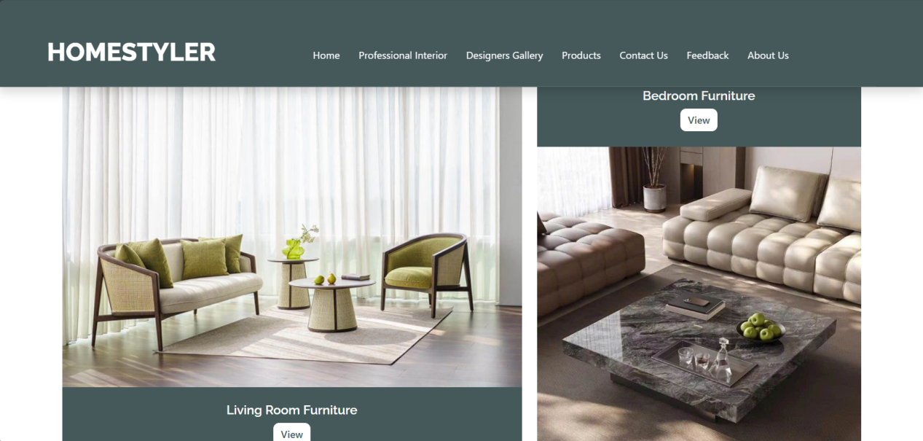

A home interior design management Website acts as a centralized platform where users can view various interior designs, accessories, and products that can enhance their homes. They can also view information about different professional interior designers and their rates, work

experience, and more on a single platform instead of multiple Websites.

**Project Costs Display:**

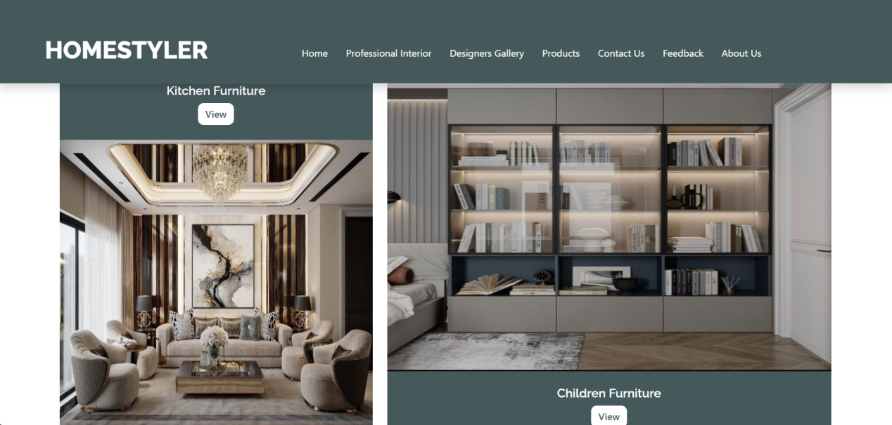 With the ever-increasing number of design options available, it is easy to lose track of projects and their associated costs. A home interior Website enables users to estimate costs by viewing cost of different designs, accessories, and products. By having a clear overview of items that their projects may require, users can make decisions as per their budgets more effectively.

**Convenience and Time Savings:**

Home interior design Website revolutionizes the way people approach home decor by offering a digital hub for inspiration and planning. This online platform brings together diverse design elements, from furniture to color schemes, in one easily accessible space. Users can explore curated collections, trending styles, and innovative ideas from designers worldwide, all from the comfort of their own homes. The Website allows individuals to draw inspiration from real-world examples.

**Proposed Solution**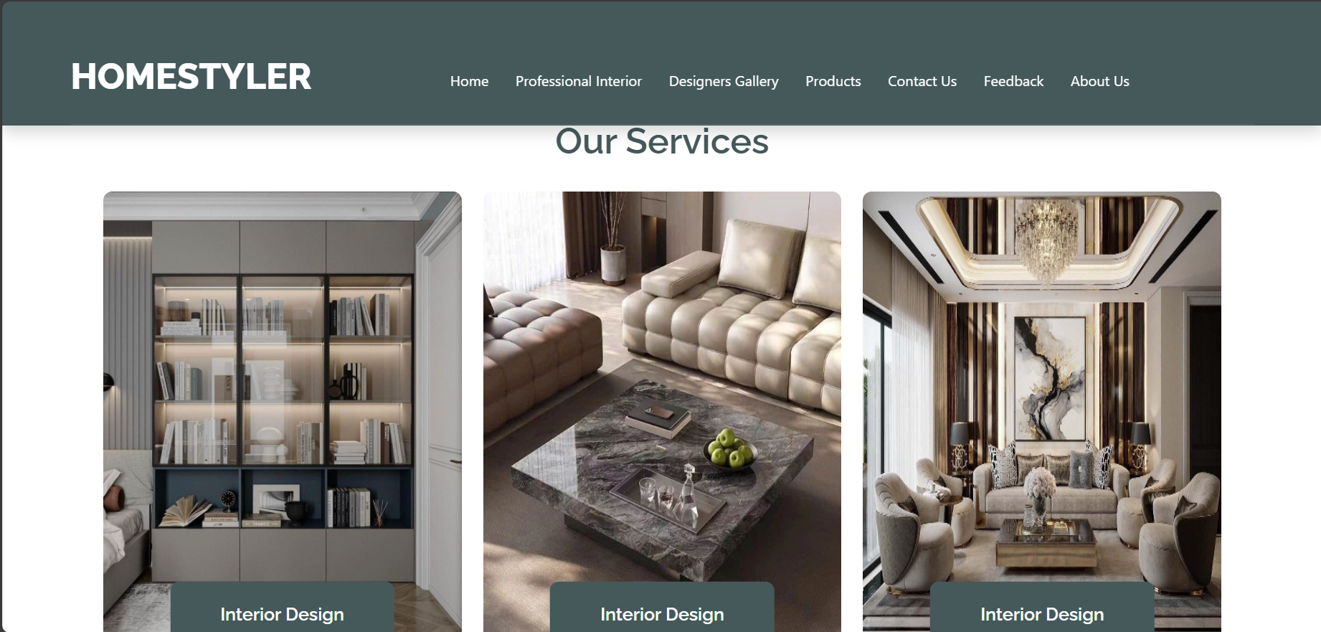

The proposed solution is to create a Website called 'HomeStyler' that allows users to view home interior design elements and inspirations on one centralized platform.

The Website should provide features such as displaying design images, accessories, and products to improve home interiors.

It should also display prices of different designs and accessories and provide searching, sorting, and filtering functionalities. The site can display details of professional interior designers along with their profiles and rates.

**Scope of Project**

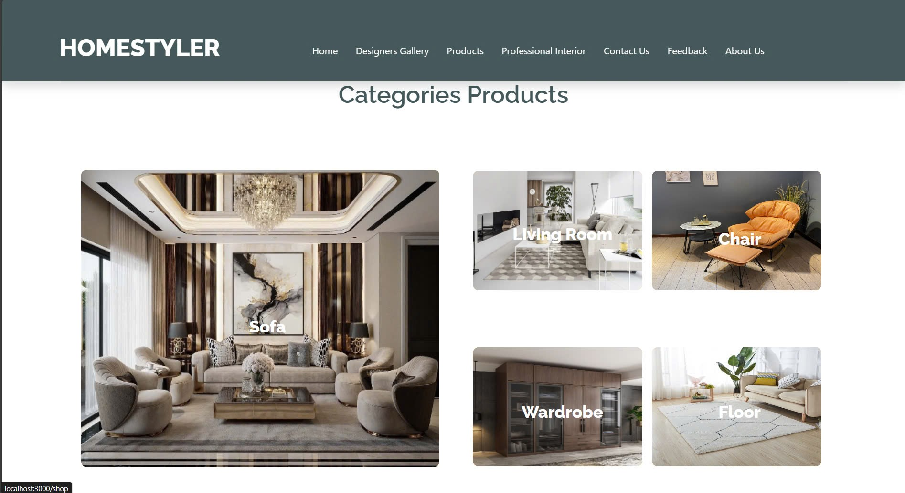

HomeStyler will be a responsive and visually appealing Website to be used by individuals interested in home interior design.

The Home Interior Design Website will be designed to help users visualize and select interior design products and ideas. It will provide a wide range of products and sample room designs to cater to various user preferences and requirements. Profiles of professional interior designers will also be available on the site.

**Design Specifications**

Hardware

Intel Core i5/i7 Processor

16 GB RAM

Color SVGA

500 GB Hard Disk space

Mouse

Keyboard

Software

**Technologies to be used:**

IDE: Visual Studio Code

Frontend: HTML5, CSS3, Bootstrap (optional), jQuery, JavaScript, Figma Toolkit, ReactJS 18

Data Store: JSON

**Sitemap**

**Data flow diagram**

- Home -> navigate to -> end of product display

- Home-> navigate to -> professional interior-> view homestyler partners

- Home -> navigate to -> designers gallery-> navigate to-> products-> view product combo

- Home -> navigate to -> products-> navigate to-> products-> view product details

- Home-> navigate to -> contract us -> navigate to-> view company address-> navigate down-> contact us section

- Home -> navigate to-> feedback-> navigate down-> our product reviews section

- Home -> navigate to -> about -> navigate down-> view about our history